**Protocol for Guided Reconstruct Cropper**

Given a specific object within a series of section images, the program will create a new set of files with the images cropped around the object. The intention for this program is to cut time on loading images in the RECONSTRUCT software; the cropped section images will take less time to load. New traces made on these files can be merged back to the original set of files.

1. If Python is not already installed on your computer, download the latest version for Windows at <https://www.python.org/downloads/>
   1. Run the EXE file that is downloaded. The installer screen should then pop up:

Please ensure that “Add Python [version] to PATH” is checked – it is not checked by default. After confirming this, click on “Install Now.”

* 1. Once the installation has finished, a message saying “Setup was successful” will be displayed. At this point, you can close the window. Python is now successfully installed on your computer.

1. Next, you will want to download the necessary modules (opencv-python and Pillow) to run the program.
   1. Open the Command Prompt by typing “cmd” into the Windows search bar.

* 1. The Command Prompt itself should look like this:

* 1. Type in the following command:

pip install opencv-python

* 1. After waiting for the prompt to finish, type in another command:

pip install Pillow

* 1. When finished, the Command Prompt should look like this:

If there is any yellow text, you can ignore it. You have now downloaded the two modules necessary to run the program in Python.

1. Download the Python code from <https://github.com/julian-falco/GuidedReconstructCropper> by clicking on the green button that says “Code” and clicking “Download ZIP.” The program will be downloaded as a zipped folder.

1. Open the zipped folder and run the Python file (GuidedReconstructCropper.py)
   1. You can do this by double-clicking the file.
   2. Feel free to extract the contents of the zipped folder and/or run the program in IDLE.
2. Once the program starts running it will ask for the following:
   1. The name of the series
      1. The program assumes that the files will all be named after the series name and that the image files are TIF files (eg. ABCDE.SER, ABCDE.1, ABCDE.001.TIF)
   2. The number of sections in the series
      1. Include the 0 section; for example, if there are sections 0-200 in a series, then there are 201 sections.
   3. The name of the object on which the crop should be centered
      1. This is the main point of the program – to crop around the center of a specific object. Ensure that the object is typed in correctly, as the program is case-sensitive. If there are any sections that do not have the object, the program will use the last known location for the object.
   4. The cropping radius in microns
      1. Five microns tends to work best with cross-sectioned dendrites, but you should adjust as needed.
   5. The number of pixels per micron in the series
      1. If you do not have this number, there is a way to check it in Reconstruct.

Section > Zoom > Actual Pixels

Section > Zoom > Magnification

The number displayed will be the number of pixels per micron.

* 1. The file path for the folder containing the original series
     1. You will need to find the folder containing the Reconstruct files in your file explorer and copy the file path (circled in red below):

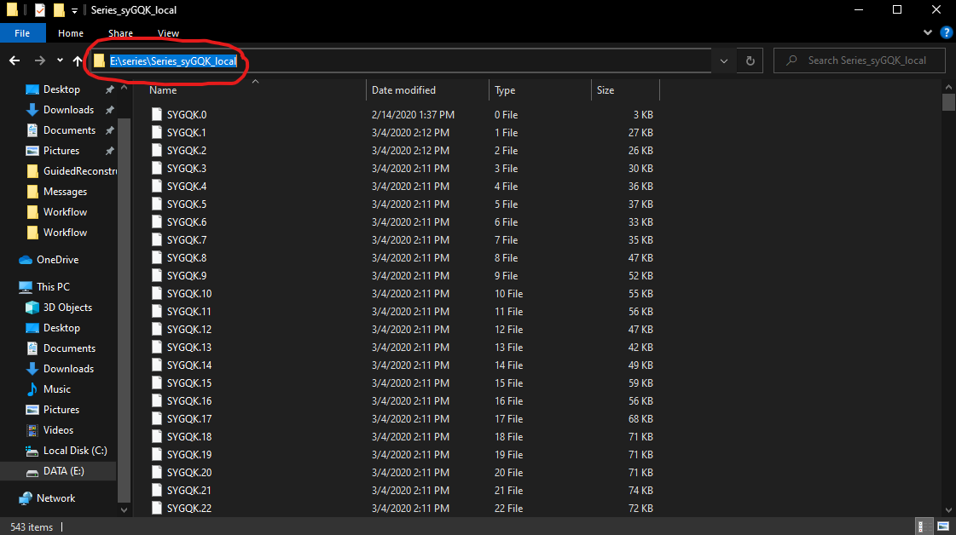

Paste this exact path into the program.

* 1. The file path for an empty folder that will contain the new Reconstruct files
     1. The program will create an entirely new set of files – section files, image files, and a series file. Create an empty folder and repeat what you did in the previous step to copy its file path. Paste this path into the program.

1. At this point, the program should start running on its own. If the window displays an error, there may have been something that was entered in wrong – re-run the program and double-check that everything is entered correctly. The program will take several minutes to run. After the program finishes, you will receive a message saying that it has run successfully.